**How do we produce the beginning /r/ sound?**

1. **Make the /gr/ face**



1. **Move your mouth from little to big**

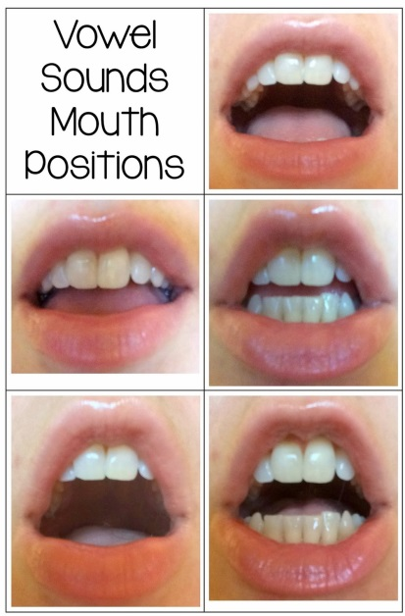

1. **NO SMILING!!!!!!!!!**